*Updated 4/26/2021

Billing for COVID Vaccine Administration; Frequently Asked Questions

Q: Can your health center bill for the COVID vaccination?

A: The vaccine itself is likely to be paid for through funding authorized by the Coronavirus Aid, Relief, and Economic Security (CARES) Act. While providers cannot bill payers for vaccine doses they receive for free, providers will be able to submit claims for the administration of the vaccine to some payers.

Q: What codes should be used to bill for the administration of the COVID vaccine?

A: The CPT Editorial Panel approved the addition of six Category I codes, 0001A, 0002A, 0011A, 0012A, 0021A, 0022A. These administration codes are unique to each vaccine and dose.

See chart below, rows in yellow indicate vaccine administration codes

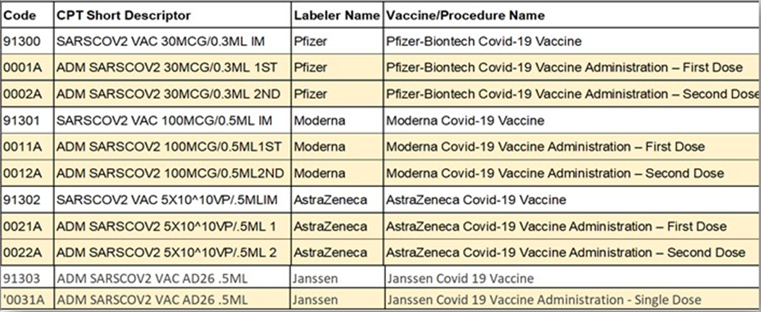

IMPORTANT REMINDER: Providers should not bill for the product if they received it for free.

Q: Can FQHCs bill Medicare for COVID Vaccine Administration? **Update**

A: Suppose a qualifying face-to-face encounter occurs at the time of vaccine administration; an FQHC should include the cost of the COVID-19 vaccine administration along with the encounter on the claim. Reporting the administration codes is considered “informational only” when billed with an encounter, and an FQHC received reimbursement for the encounter. The FQHCs cost report will need to include the vaccine, and reimbursement will occur at cost settlement.

When the government provides COVID-19 vaccine doses without charge, only include the administration code as “informational only.” If the FQHC received the vaccine for free, do not include it on the claim (e.g., do not show a $0.00 on the claim).
Administration of the COVID-19 vaccine does not count as a face-to-face encounter when it is the only service provided and should not generate a claim. If a provider bills the vaccine administration without an encounter included, the claim will return as un-processable.

Q: Can FQHCs bill Utah Medicaid for COVID Vaccine Administration?: **Updated**

A: COVID Vaccine Administration, No Office Visit: COVID Vaccine Administrations billed without an office visit now qualify for payment at the PPS Rate. Claims must include additional line items to receive payment.

Both Managed Care and Non-Managed Care Members: Please include the standard HCPCS code T015 as the first line item, followed by the Vaccine Administration Code as the second line item. The corresponding Vaccine Code is the third line item.

COVID Vaccine Administration, with an accompanying Office Visit: No accompanying office visit is required for the vaccine administrations to qualify for the PPS rate. Please note that only one PPS rate payment will be received when an accompanying office visit does occur.

Non-Managed Care Members: Do not submit separate claims for the COVID Vaccine Administration and the Office Visit. Submit a single claim containing all charges to the state plan with HCPCS code T1015 listed as the first line item, the Evaluation, and Management code representing the office visit as the second line item, the Vaccine Administration code as the third line item, and the corresponding vaccine code as the 4th.

Managed Care Plan Members: Do not submit separate claims for the COVID Vaccine Administration and the Office Visit. Submit a single claim containing all charges to the ACO/UMIC with HCPCS code T1015 listed as the first line item, the Evaluation, and Management code representing the office visit as the second line item, the Vaccine Administration code as the third line item, and the corresponding vaccine code as the 4th.

Q: What diagnosis code (ICD-10) should be listed on the claim when billing for COVID vaccine administration?

A: Use Diagnosis Code Z23 on the claim to indicate that the provider saw a patient for prophylactic vaccination against a disease.

Q: Will patients have a share of cost under their insurance for COVID vaccine administration?

A: No, During the PHE, payers must cover vaccine administration without cost-sharing for patients in non-grandfathered groups and individual plans, whether vaccine administration occurred by an in-network or out-of-network clinician or other vaccine providers.

Q: Should health centers also bill for 99211 (nurse/shot visit) or any other encounter along with the vaccine administration?

A: Administration of these vaccines does not count as a visit when the only service involved is administering the COVID-19 vaccine. If there was another reason for the visit, the RHC/FQHC should bill for the visit..

Q: Can FQHCs and RHCs “roster bill” Medicare (submit one claim for multiple patients) for COVID vaccine administration?

A: No, the “Type of Bill” codes used by FQHCs and RHCs are not among those that have received approval to submit multiple patients per claim, aka “roster bill,” for vaccine administration.
Individual claims will need to be submitted.

Q: Can Medicare Advantage plans be billed for COVID vaccine administration?

A: Medicare Advantage plans are required to cover vaccine administration without cost-sharing.
Providers will submit claims to their respective Medicare Administrative Contractor using the product-specific CPT codes for each vaccine. (Utah’s MAC is Noridian.)
See link: https://www.cms.gov/files/document/covid-19-mac-hotlines.pdf

Q: Can health centers seek reimbursement for COVID vaccines administered to uninsured patients?

A: Yes, providers administering the vaccine to people without health insurance or whose insurance does not provide coverage for the vaccine can request reimbursement electronically through the Health Resources & Services Administration (HRSA) COVID-19 Claims Reimbursement to Health Care Providers and Facilities for Testing, Treatment, and Vaccine Administration for the Uninsured Fund. Claims will be reimbursed generally at Medicare rates.

*Note: Instructions for enrollment in the HRSA program for the uninsured were previously distributed for the purpose of billing for COVID testing provided to uninsured patients. See Reference E in the final pages of this document.

Q: Do we need to verify if uninsured patients are eligible for Medicaid before submitting a claim to the uninsured program?

A: When a claim is submitted, providers must attest that to the best of their knowledge; the patient was uninsured when seen. This scenario also includes claims for vaccine administration.
Providers may submit a claim for uninsured individuals before Medicaid eligibility determination is complete. However, if the provider learns that the individual was retroactively enrolled in Medicaid as of the service date, the provider should return payment.

Additional Reference Materials:

Reference A:
(New) Joint Letter to CMS on FQHC payment changes needed for COVID 19 Vaccine Administration.
www.aafp.org/dam/AAFP/documents/advocacy/payment/medicare/feesched/LT-CMS-COVID-19VaccineReimbursement-021921.pdf

Reference B:
AMA: Covid-19 Vaccine Product & Admin Codes;
https://www.ama-assn.org/system/files/2020-11/covid-19-immunizations-appendix-q-table.pdf

Reference C:
AMFP: COVID-19 Vaccine Coverage Requirements and Preliminary Payment Guidance; https://www.aafp.org/dam/AAFP/documents/advocacy/prevention/vaccines/ES-COVIDVaccineCoveragePayment-121020.pdf

Reference D:
Medicaid.gov, Coverage and Reimbursement of COVID-19 Vaccine Administration, and Cost Sharing under Medicaid, the Children’s Health Insurance Program, and Basic Health Program; https://www.medicaid.gov/state-resource-center/downloads/covid-19-vaccine-toolkit.pdf

Reference E:
HRSA: COVID-19 Claims Reimbursement to Providers and Facilities for Testing, Treatment, and Vaccine Administration for the Uninsured;
https://www.hrsa.gov/coviduninsuredclaim/frequently-asked-questions

