**COVID Vaccine Administration to be paid by Medicaid at PPS Rate:**

Coverage for administration of the COVID-19 vaccine has been updated to allow FQHCs and RHCs reimbursement at the PPS Rate.

**Objective: This email is intended to provide instruction for claim submission moving forward to accommodate the changes in payment.**

**Effective immediately, please reference the workflow and summary below for all patients with Medicaid or Medicaid Managed Care Plans receiving COVID Vaccinations:**

**COVID Vaccine Administration Claim Submission Workflow**

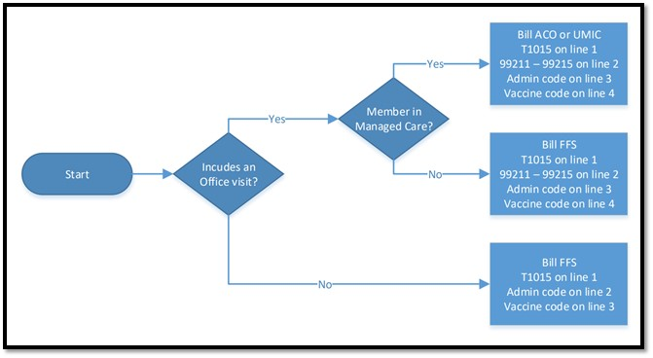

**COVID Vaccine Administration, No Office Visit:** COVID Vaccine Administrations billed without an office visit now qualify for payment at the PPS Rate. To receive this payment claims must include additional line items.

**Both Managed Care and Non Managed Care Members:** Please include the standard HCPCS code T015 as the first line item, followed by the Vaccine Administration Code as the second line item, and the corresponding Vaccine Code listed as the third line item.  Claims should continue to be submitted to state plan.

(Example below, Moderna)

             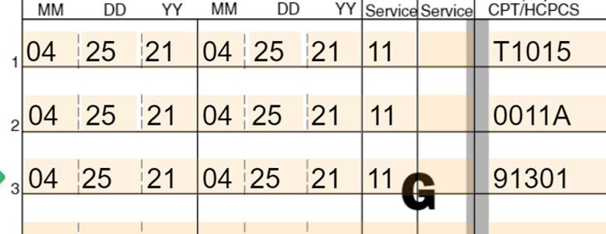

**COVID Vaccine Administration, with an accompanying Office Visit: N**o accompanying office visit is required for the vaccine administrations to qualify for the PPS rate. Please note that in instances that an accompanying office visit does take place only one PPS rate payment will be made.

**Non Managed Care Members:** Do not submit separate claims for the COVID Vaccine Administration and the Office Visit. Submit a single claim containing all charges to the state plan with HCPCS code T1015 listed as the first line item, the Evaluation and Management code representing the office visit as the second line item, the Vaccine Administration code as the third line item, and the corresponding vaccine code as the 4th.

**Managed Care Plan Members:** Do not submit separate claims for the COVID Vaccine Administration and the Office Visit. Submit a single claim containing all charges to the ACO/UMIC with HCPCS code T1015 listed as the first line item, the Evaluation and Management code representing the office visit as the second line item, the Vaccine Administration code as the third line item, and the corresponding vaccine code as the 4th.

(Example below, Moderna)

Office Visit Code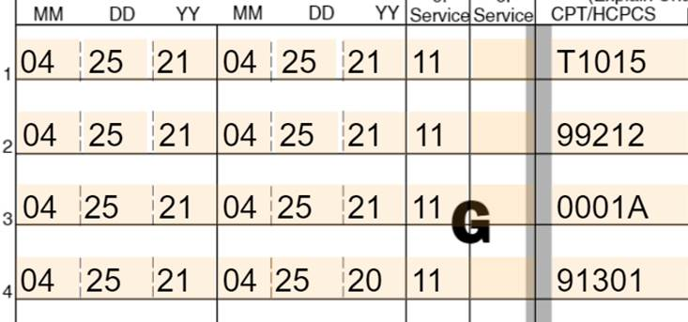

0011A

**Full List of Vaccine and Admin Codes**

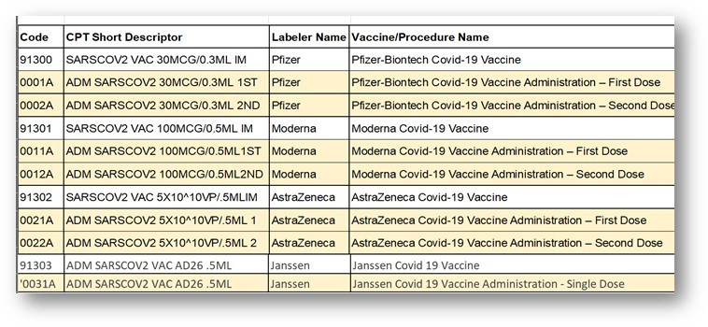

**Claims for COVID Vaccine Administration billed to date:**

The payable amount is retroactive.  If you have received reimbursement other than the PPS, please work with the Bureau of Medicaid Operations to reprocess the claim. **Do not submit corrected claims until further instruction is provided.

Please do not hesitate to reach out with questions.